Kathy’s Korner
Kathy Bridges, Linn County, KCAA President

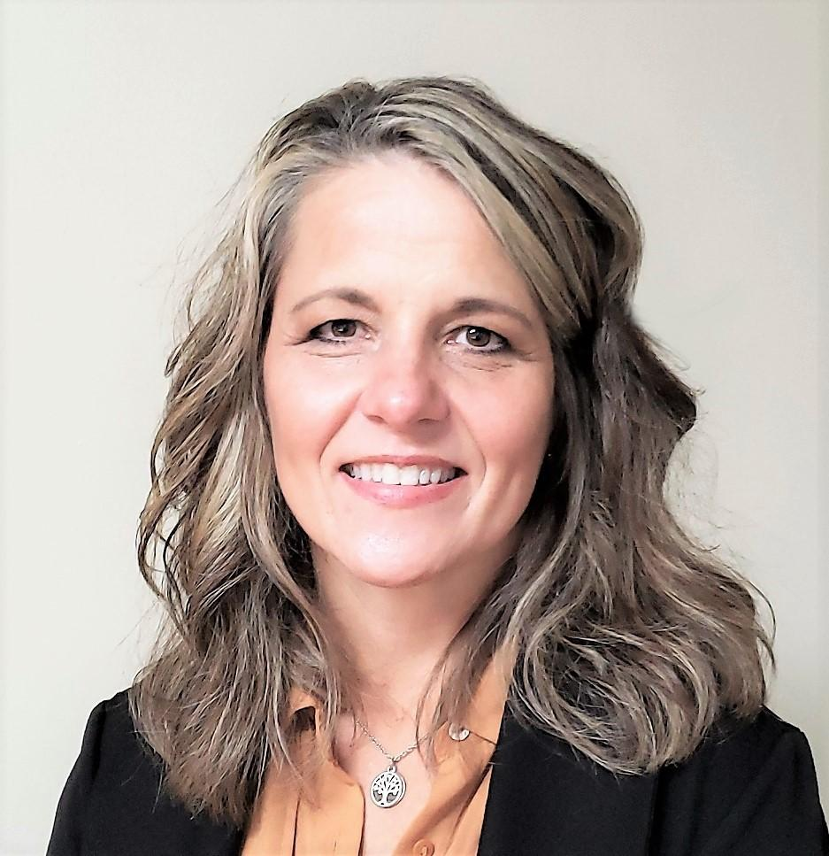

This is an unprecedented year.

As each of you read this, we are nearing the end of the 2022 valuation cycle. For many, including myself, these past few months have likely been filled with a high level of anxiety as market values have just kept ticking up at record highs, not only with real estate values, but on many personal property items we must value as well. In addition, some counties may be experiencing more appeals as a result of the higher values.

People who know me know that I try to find the positive in negative situations and I have truly had that challenge over the past year. I’d have to say, in my 29 years of being in mass appraisal, this last year has presented many firsts, and trying to keep a positive mindset has been important.

The challenges kept presenting themselves during the months leading to values going out. As
I was conducting analysis for 2022 in a brand new county, I was making large upward adjustments to pretty much everything I touched. My inner self kept telling me – ‘follow what the indications are showing and keep moving ahead.’ After each phase of analysis, I do have to confess that I would then call another county appraiser and talk with him or her about what our county was experiencing and to see if they were seeing the same trends and upward increases as I was, and to no surprise - they were as well. So, knowing that I was not the only county appraiser dealing with this craziness, and that l had others to lean on for support, is a great feeling since we are all in this together.

On another positive note, I was very excited to see the public relations amp up in many counties! As I perused the web and on social media, I found numerous county appraisers using public relations as a tool to inform the public of the increases in valuations within their communities. PR is a very scary thing to many, but can also be rewarding, and I applaud each of you that took that leap this year to inform the public in your counties! In addition, remember that your internal public relations are just as important. By keeping your staff, commissioners and even other departments informed within the courthouse can really make a difference.

“Knowing that I was not the only county appraiser dealing with this craziness, and that l had others to lean on for support, is a great feeling since we are all in this together.”

Speaking of keeping informed, the legislature is in session, and it is very important to educate ourselves on what is happening in Topeka and what could affect our mass appraisal world. In January, we held our KCAA legislative reception and had a great turnout. Although we did not have much on our agenda at that time, as this session moves forward, appraisal and valuation issues will likely be on the forefront.

A reminder to everyone, the KCAA Annual Conference is a time to learn, build relationships and have fun, so be sure to get signed up for the conference that is scheduled for June 5 to 8 in Wichita at the Drury Hotel. Many fun events and educational workshops/sessions are planned along with a great time for all.

Lastly, I would be remiss if I did not mention several significant losses within our mass appraisal family. The loss of Mark Low and Greg McHenry is still weighing on my heart with disbelief. These men were very different, but very genuine individuals and very passionate about our profession, touching many lives along the way. Each definitely left a legacy and will always be remembered.

May the rest of this year be filled with peace, happiness, love and a time to create new memories, and as indicated in the last newsletter – always remember that we are better together!

